**Resume Preparation – Reading Material**

Overview:

The whole purpose of a resume is to grab the attention of recruiters and get an interview call. Many a times resumes remains unnoticed by recruiters, just due to their bad shape and size. As there is a tough competition for jobs, you cannot afford to lose any opportunity, just for not having a good resume. Though an art, learning how to build a good resume is not very difficult. You just need to know a few nuances of it. This topic helps you in knowing the components of a resume, designing an effective and persuasive resume and proofreading and finalizing the resume.

**Objectives:**

This reading material is designed to help you:

* Understand the relevant components of resume
* State clear objective of sending the resume to a particular recruiter for a particular position
* Place short and straight content under each heading of your resume
* Finalize your resume by proof reading for format and grammar

**Introduction to Resume Preparation**

Your resume is a mirror of your professional identity. Recruiters generally screen in or out the candidates by looking at a few keywords and their positioning in the resumes. They, typically have just 15 to 20 seconds to screen a resume. So, all you **need is** to learn the keywords and how to position them in your resume so that in that small 15-20 seconds, it grabs the attention of the person screening it.

Resume building is a three-step process:

* Identifying and applying relevant components,
* Designing your resume in terms of format and content and
* Proofreading and finalizing it for a particular position.

**Components of Resume**

The components of a resume are the specific headings in a resume to segregate professional and personal details of the applicants.

Apart from your official name, the other key components of any resume should be:

* Contact Details
* Job Objective,
* Summary,
* Skills & Achievements,
* Special Skills,
* Projects and
* Qualification.

There are a few more components, which you need to use only when these are asked for. These components are:

* Personal Details,
* Hobbies,
* Passport/Visa Details,
* Co-curricular activities and
* References.

Note: Do not put your signature in your resume.

### Contact Details:

The first thing first. The first part of your resume must contain your contact details. The postal address is a bad idea as email and mobiles are most preferred modes these days.

Generally the contact details must appear on the left side top portion of your resume, as most people read that way.

Just provide only one email ID and one mobile number. If you are accessible on any landline, then you may provide that number too.

Mobile numbers and land line numbers must prefix the Country Code. Additionally, to the landline number prefix the STD code.

Lastly, provide the contact information that is current and in use. Don’t provide numbers of friends or relatives, unless you are really not reachable.

### Job Objective:

Although optional, a job objective (sometimes also called as Statement of Purpose) is the statement that tells you the direction you want to go, your work preferences, and serves as a focal point for employers to review and analyze your resume. So, if included, the objective plays a very vital role in the resume screening process.

The objective statement allows employers to immediately identify the kind of position you want. If you are looking for jobs in a number of different fields, you need to have a different job objective for each position. To address this, prepare some resumes without objective statements or tailor each resume to the specific job you seek. Do not write an objective that is vague and meaningless, if it isn't specific, don't include one. It may contain following parts:

* The level of the position - This can be anything, like, internship, full time, entry level, experienced, supervisory, or executive.
* The skills you hope to bring to the position. You need to use action words (verbs) to describe them.
* Position - If you are responding to a job listing, look at the text of the listing to find out what the employer calls the position. This is the actual title, such as consultant, investment banker or field or industry in which you hope to work..

To write an effective objective statement, all you need is to pay attention to the following three things:

* Is it an employee focused (specific) objective statement?
* Is it focusing on results!
* Is it Short and Simple?

For example:

"To obtain a managerial position with responsibilities of managing people, interfacing with customers, and working with highly technical software or hardware applications."

"To obtain a *middle/upper-level healthcare management position with responsibilities including problem solving, planning, organizing, and managing budgets.*"

“To obtain a full-time position in the field of information technology with an emphasis on technology integration; special interests include software design, consulting, systems analysis.”

Note: Avoid using clichés or jargon, such as, “To contribute to the profitability of an employer” or “A challenging position offering an opportunity for growth and advancement.”

The following are some memorable or employer-oriented resume objective samples collected from the *CareerJournal.com* and *Robert Half*:

* "To work for a company with a warm environment and great pay."
* "________position allowing me to fully utilize my nursing skills and attributes and providing professional advancement opportunities."
* Does that resume objective statement say anything to you about what this candidate has to offer?
* To get a challenging job as a Customer Service Manager so that I can learn more and excel in my career.

The following are some examples of BAD objectives:

* *“To obtain a position at Mercedes”.*Managers will think "What position? The job is not specific, and although it includes the company's name, the employer will just think you want to work there only for the brand.
* “*To have a career-oriented position where my skills can be utilized to reach goals.*” First off... "career-oriented" doesn't specify the position. And "reach goals"... what goals?? This is too vague, and it includes the word utilize which, as I explained earlier, is used too many times by other people.
* “*An office position with the opportunity for growth and advancement.*” Well, everyone wants to advance in their jobs. But this is not specific and will make employers feel that you only want a job to get promoted.
* “A dedicated worker with knowledge in customer service who can provide exceptional skills and operate in a fast-paced environment to the best of my abilities.” This is too long and boring. And, there are too many general words and phrases. Overall, it's vague and still doesn't explain your immediate goal.

### Summary:

The Qualifications Summary is a succinct, eye-catching paragraph that showcases your most effective skills and experience as they pertain to your job search. You can include experience, credentials, work ethics, and any other statements that inform hiring managers why you’re the ideal candidate for the job. This component of a resume is essential, given that hiring managers generally afford no more than 30 seconds to an applicant’s resume, unless they’re enticed to read further. In the nutshell, it plays a crucial role in informing the recruiter about your key attributes and strengths and gives you an opportunity to:

* Highlight your strengths
* Invite the recruiters to read your detailed resume
* The summary should consist of 4-5 specific points-either bullet points or in one paragraph.

Your professional summary should?

* Contain 3-6 sentences or bullet points.
* Specify:
* Your experience and accomplishments that are most relevant to the job that you want.
* Career goals are clearly evident based on your experience and accomplishments.
* Avoid the words "I," "me," or "my." These words could be perceived as self-centered. Remember, it's not about you. It's about the company. Tell the company what you have to offer them.
* Use resume action words.
* Describe specific results using numbers and/or percentages, wherever possible.

The following are a few examples of professional summary:

Example1:

“*Enthusiastic professional with proven ability to design and deliver training to a variety of individuals on topics ranging from safety to computer programs. Currently pursuing a Bachelor’s in Human Resource Management with a major in Training and Performance Improvement. Possesses easily transferable skills such as organization, working with teams, and writing skills.*”

Example 2:

“*Dedicated and enthusiastic professional with over six years experience in higher education advising. Consistently receive outstanding feedback for workshops and sophomore level exploration courses. Proven expertise in establishing rapport and building trust with students from a variety of backgrounds, including first generation college students. Possess strong written and verbal communication skills and ability to partner across departments to meet the needs of students.*”

Example 3:

* Energetic career development professional with MS in Counseling and Student Personnel and over 3 years of combined experience in career services and human resources.
* Experience working with a diverse population of traditional and nontraditional students, both in person and in an online environment.
* Innovative, strong presenter with experience leading webinars and facilitating in‐person workshops.
* Proven ability to leverage technology and develop and deliver impactful career‐related content.

Note that the Objectives are different from the Professional Summary. A professional summary is longer and provides more detail than an objective statement. Professional summaries identify the type of position you are seeking and provide lengthier descriptions of skills and qualifications. Generally, professional summaries are most helpful for experienced professionals who aim to demonstrate the applicability of skills from a range or depth of past experiences for a specific type of position. Professional summaries are useful for networking resumes and resumes uploaded to job search websites.

### Skills:

You will be hired only for your skills. So, this component is most important and mandatory in the resume. This is the place to put important and/or interesting information that does not fit anywhere else. With the advance of technology, it is increasingly important to include a section on computer skills. This should include any of your knowledge of computer programs, hardware, software, database knowledge, and/or Internet functions. If you have any other notable skills, such as foreign languages, musical talents, or writing skills include these here.

Put your skills and accomplishments in order of importance for the desired career goal. Preferably segregate technical and professional skills.

### Achievements:

Followed by the skills, should be your achievements (if any) complements some of your skills, like, “*Received Best Programmer award during training…*”

If you have received any awards or honors, or been involved in campus or community organizations, such as athletics, clubs or student government, you should mention them in this section. Identify any leadership roles that you had in these organizations. If you have too many organizations to list, choose the ones that have the strongest connection to the type of job you seek, don't pad this section with organizations you joined "in name only." Employers may ask you about your involvement during an interview.

Note: Don’t **self-qualify** your skills like “***Best programming*** *knowledge in Java…*” You may be one, but let it come from the interviewer.

### Special Skills:

Special skills should always be presented up-front so that a hiring manager knows what you can do in addition to the required skill that you posses. Like, if you are a Java programmer and you also learnt software testing, then for the Java Programmer position, Software Testing can be the special skill.

Special skills will include:

* Office procedures
* Linguistic capabilities
* Any skill that’s industry-specific for the job you’re seeking

### Project / Project Details:

The details provided by you under this component helps the Hiring Manager to understand how well you know the project execution and its dynamics.You can use the STAR approach to state the details of your project:

State the need / requirement of the project (S/w Application or S/w Testing task) to the client. If possible include the challenges.

Task: Specify your role and responsibilities in the project in terms of tasks that you need to perform.

Action: Specify what contribution you have done which are part of your responsibility. Also mention, if any additional actions you have taken to handle the situations, which otherwise are not your responsibility.

Result: Use cone approach to state the results. First you need to tell how your contribution resulted into successful development / testing, and then tell about overall result, like, “*Completed the project in the given time and budget…*”

Another way of detailing your projects is to use the following template:

Project Name:

Platform:

Client:

Duration:

Role:

Team Size:

Description:

Responsibilities:

### Qualification:

This is an important component. Many a times, employers are particular about the qualification of the candidates. So, you must provide your qualification details. Your qualification details must:

* Be in a tabular form
* Be placed in reverse chronological order,
* Contain the names of institutions and university, Course, certificates, grades / marks and the year of course completion.

Include your school qualification details too from 10th Class / Matriculation onwards.

Don’t club your certification course/trainings and academic courses. If you have undergone some certificate courses / training, then place that information under another sub-heading as ‘Certificates’. Do provide grades.

In case you have cleared any certification examination for any particular skill or technology and the certification authority authorizes you (in writing) to use their certification logo on your resume, then place such logos on the right side, in the header section of your resume.

**Designing the Resume**

Resume designing is the key task in resume preparation. Resume designing is done in three steps:

* Identifying appropriate content,
* Identifying the format and
* Adding content in the format.

### Identifying Appropriate Content for Your Resume:

You may have several good things about yourself, which you want to portray in our resume to impress the Hiring Manager. But, not every good thing about you will impress the recruiters. So, it is important for you finalize the points that you want to add to your resume. The best tool for the purpose is a mind map.

To begin with, create a mind map. This is a very simple activity. All you need is a piece of blank paper and a pencil. Write your name at the center of the paper (If possible, circle it)**:**

Now think each aspect of yours, like Skills, Qualification, Hobbies, Trainings, etc. Place these items around your name (Again in circles, if possible) and join them to your name using straight lines.

Now each circle around the core is one aspect about you. But that’s just aspect, now you need to list relevant information around each aspect, like, for qualification; you may have your degree, if you have completed post graduation, doctorate, post doctoral studies, etc, Then all these things will come around the qualification. Then for each degree you need to list several attributes like, marks, passing out year, college details, etc. Similarly you need to do it for all the aspects. Once done, the full blown mind-map may look somewhat like the following:

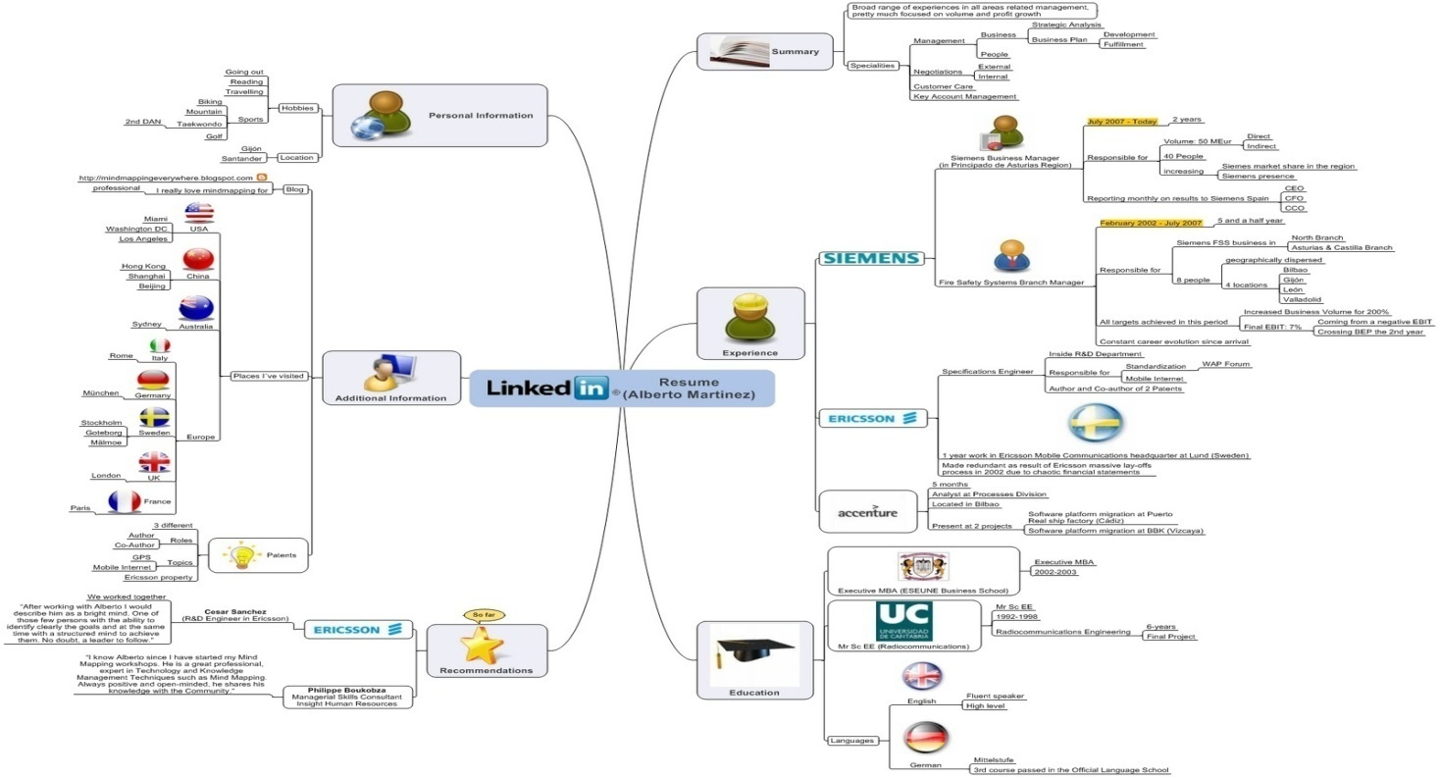

Well, this just a beginning, but it can be a great start. Once you are ready with your mind map, just go through it. You will see a complete Professional Yourself. Now, that the mind map is ready, you just need to consolidate the mind map information under appropriate headings in your resume.

The next question is what the appropriate headings are. Well, that’s easy again. Just components of a resume are your headings and you just need to map the mind map and the headings in the resume.

The next important thing is the template (i.e. The skeleton) and the sequence of headings. Microsoft Word has got many inbuilt templates for resume. Just select a decent one. Don’t go for a jazzy, flashy, colorful one. It is not appreciated. There’s one for fresh graduates too. If you don’t like the ones provided by MS-Word, then you can create your own.

Your resume should be divided into three parts:

* Header Section
* Body
* Footer

**Note:** Don’t use MS-Word’s header feature for the resume header section, as the resume header has to appear only on the first page.

**Header Section**

The Header section should contain your name (full name), just at the center, and your contact details, like mail ID and phone numbers on the left, just below your name.

The name should be in the biggest font size preferably underlined. Whether to embolden it or not depends on the font you select for the name.

The font size of phone numbers and email ID must be the same that you want to apply to the body of the resume.

**Body**

The body should contain your professional and functional details in the following structure:

**Objective** (If you want to write)

**Summary** (If you want to write):

Professional Skillset

**Educational Qualification:**

**Certifications:**

**Experience** (If you have any):

**Project details**

**Personal Details** (if required / If asked for):

**References** (If asked for)

### Placing Content in the Resume

Now that your template is ready, start placing the content under each heading. For this:

* Use KISS (Keep it simple and short)rule
* Use an easy to read fonts like:
* Serif
* Sans Serif
* Verdana
* Times New Roman
* Limit font size to 11 or 12 ( including headings)
* Do not overuse capitalization, italics, underlines, or other emphasizing features.
* Keep the paragraph format as Justified
* Maintain line spacing to 1.15 to 1.5.
* Don't overcrowd your resume; allow for plenty of white space.
* Keep the number of fonts you use to a minimum -- two at the most.

**Proofreading and Finalizing the Resume**

We cannot emphasize enough that nothing will get your resume tossed into the “NO” pile faster than careless typos. So proofread your resume several times yourself, and have at least one other person proofread it as well. Your proofread must include identification and rectification of:

**Punctuation Mistakes**:

* Check for periods at the end of all full sentences.
* Be consistent in your use of punctuation.
* Always put periods and commas within quotation marks (i.e., Won awards including the "XYZ Award.")
* Avoid using exclamation points.

**Grammatical Mistakes:**

* Do not switch tenses within your resume - be sure they are consistent for each job you list. The duties you currently perform should be in present tense (i.e., write reports), but ones you may have performed at past jobs should be in past tense (i.e., wrote reports).
* Capitalize all proper nouns.
* When expressing numbers, write out all numbers between one and nine (i.e., one, five, seven), but use numerals for all numbers 10 and above (i.e., 10, 25, 108).
* If you begin a sentence with a numeral, spell out that numeral (i.e., eleven service awards won while employed.).
* Make sure your date formats are consistent (i.e., 22/11/20105 or November 22, 2008, or 11.22.08. Choose one and stick with it.).

**Choice of Words:**

* Be on the lookout for the following easily confused words: accept (to receive), except (to exclude), all right (correct), alright (this is not a word), affect (to bring about change), effect (result), personal (private), personnel (staff members), role (a character assigned or a function), roll (to revolve).
* Use action words (i.e., wrote reports, increased revenues, directed staff).

**Other Potential Mistakes:**

* Check dates of all prior employment.
* Check your address and phone number - are they still current and correct?
* Check the number of returns separating your categories: are they consistent?
* Check abbreviation of state names. All state abbreviations are two letters - no periods. For example, Andhra Pradesh is abbreviated AP, Tamil Nadu is TN Look up other state abbreviations.

Conclusion:

The sole purpose of your resume is to effectively sell your credentials for the purpose of employment, admission to Universities, consideration for a scholarship or fellowship, or other professional purposes.

Remember; A good resume can give you an opportunity, but will not ensure you a job, but a bad resume or no resume will prevent you from even getting closer to the opportunity.